EXCEL SUMMARY AND INSIGHTS

Project Title - “SNITCH FASHION SALES”

Data Cleaning, Analysis & Visualizations, dashboards with Excel”
Project Objective:
- Data cleaning, Transforming, Using FORMULAS, creating Pivot tables, Creating Dashboards, Data visualization, XLOOKUP, VLOOKUP.
Dataset Description:
    - STRUCTURED DATA: The table in this “SNITCH FASHION SALES ”is highly organized and contains rows and columns with values.
    - PANEL DATA: There are collection of 3 years of data (2023,2024,2025).
    - INTERVAL DATA: Order date is interval data here
    - DISCRETE DATA: Unit price is non -changeable
Column Description:
Column Name | Description
ORDER_ID | Id number of the customer
FIRST NAME | Customer first name
LAST NAME | Customer last name
PRODUCT BRAND | It includes product name and its brand
UNIT PRICE | Unit price of the products
REVENUE | Generated by unit* price
UNIT PRICE | It contains value of the price
UNITS SOLD | How many units sold
CITY | Where the customer place is located
ORDER DATE | Products ordered date
SEGMENT | B2B- Business to Business  B2C-Business to Consumer

Data cleaning & transformation
It is done with FORMULAS AND POWER QUERY
FORMULAS:
- =IF(ISBLANK(F3), AVERAGE(F2:F2501),F3)
- =IF(ISBLANK([@[Units_Sold]]), AVERAGE($F$2:$F$2501), [@[Units_Sold]])
- =IF(ISBLANK(G5), AVERAGE(G5:G2504),G5)
- =IF(ISBLANK(K3),"UNKNOWN", K3)
- [Ctrl+h] to find & replace
- = MIN(H2:H2501)
- = COUNTA( D2:D2501)
- = CONCAT([@[product category]]," ", [@[Product Name]])\
- =IF(H3>0,"POSITIVE SALES","NEGATIVE SALES")
- =SUMIF(K2:K2501,"B2B",L2:L2501)
- =COUNTIF(H2:H2501,">10000")
- =XLOOKUP(N4,$S$3:$S$10,$X$3:$X$10,"NOT FOUND",0)

VISUALIZATION AND INSIGHTS
CONDITIONAL FORMATTING AND CREATING CUSTOM COLUMN
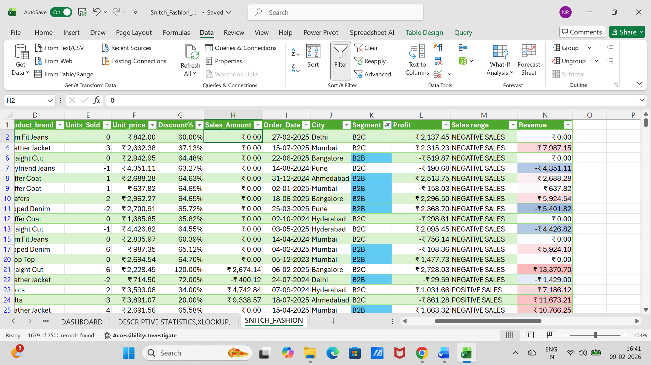

DESCRIPTIVE STATISTICS,XLOOKUP,MATCH, INDEX
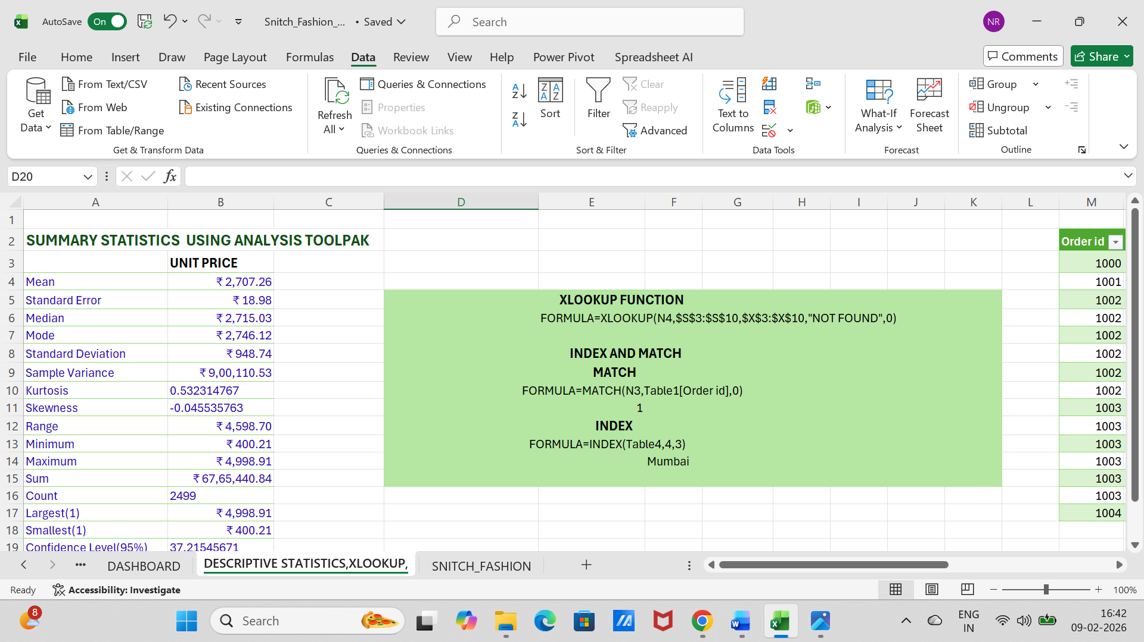
DATA CLEANING AND IF FUNCTIONS
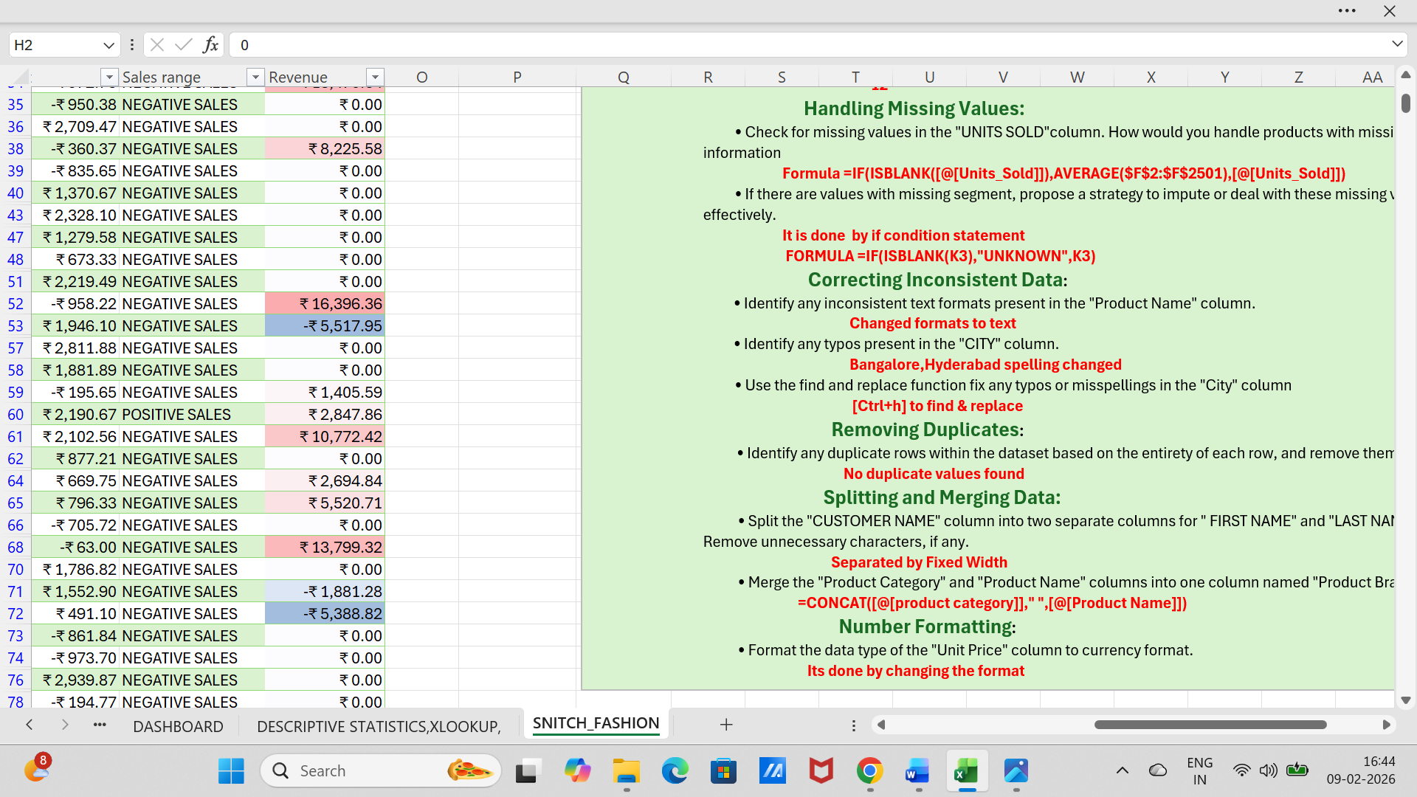

PIVOT TABLES AND DASHBOARD
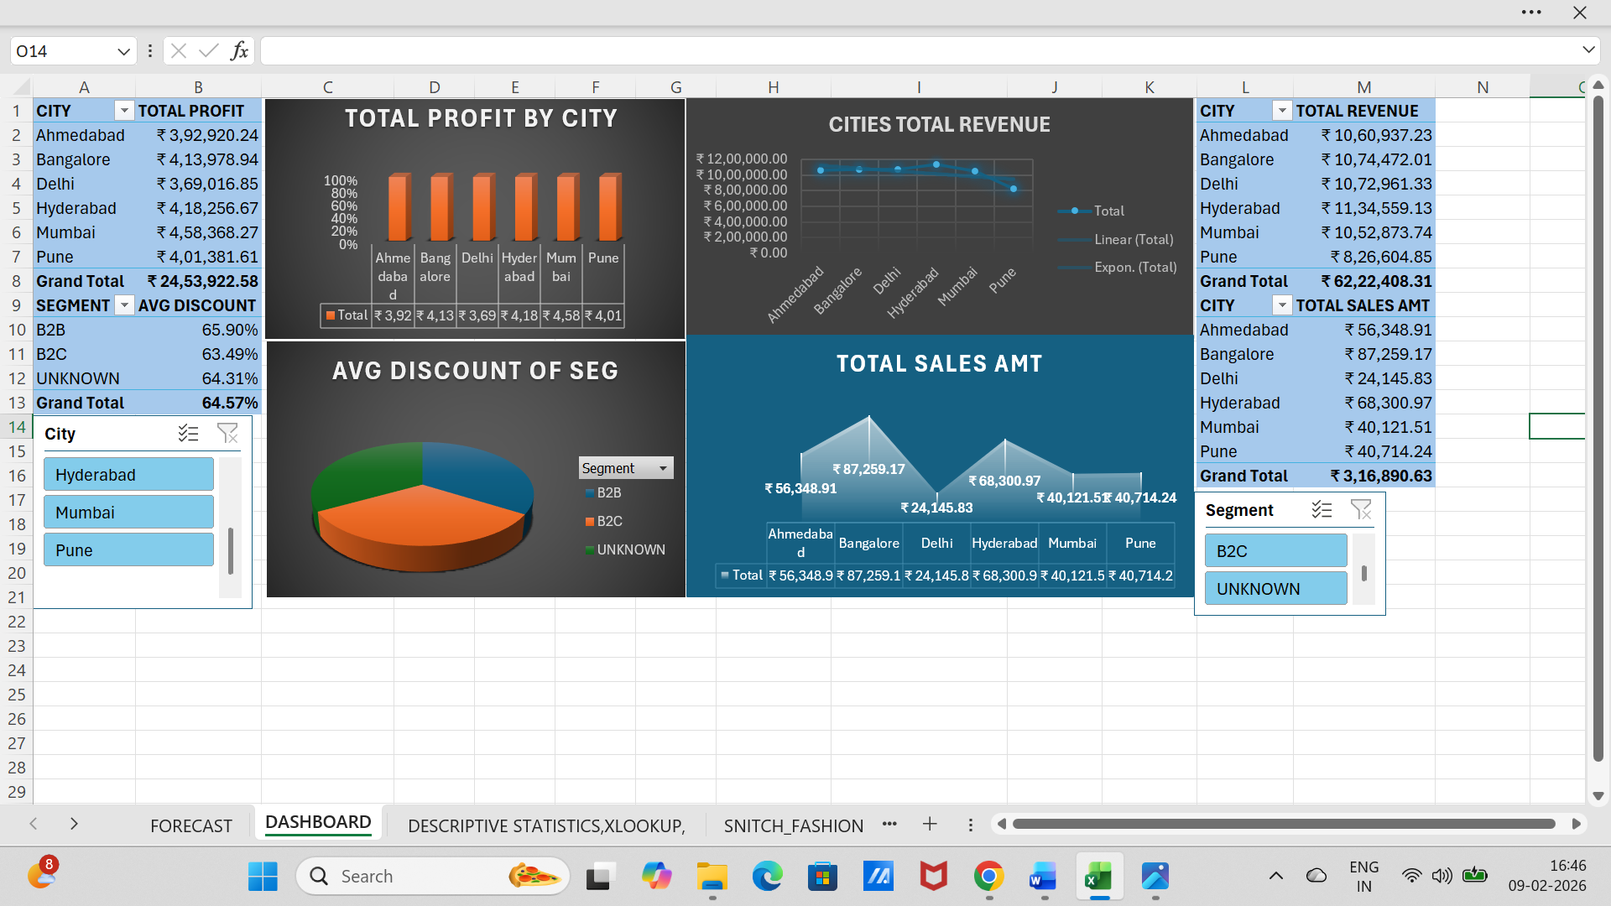
DATE FUNCTION
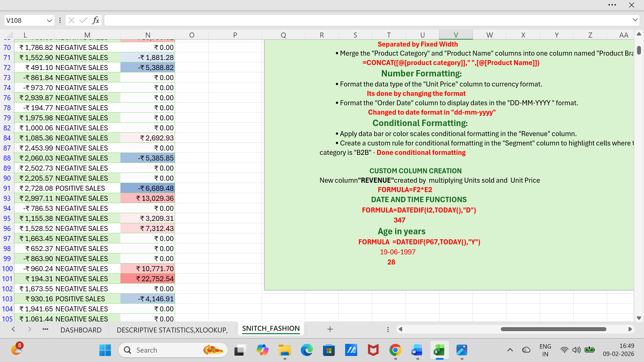

FORECAST ANALYSIS
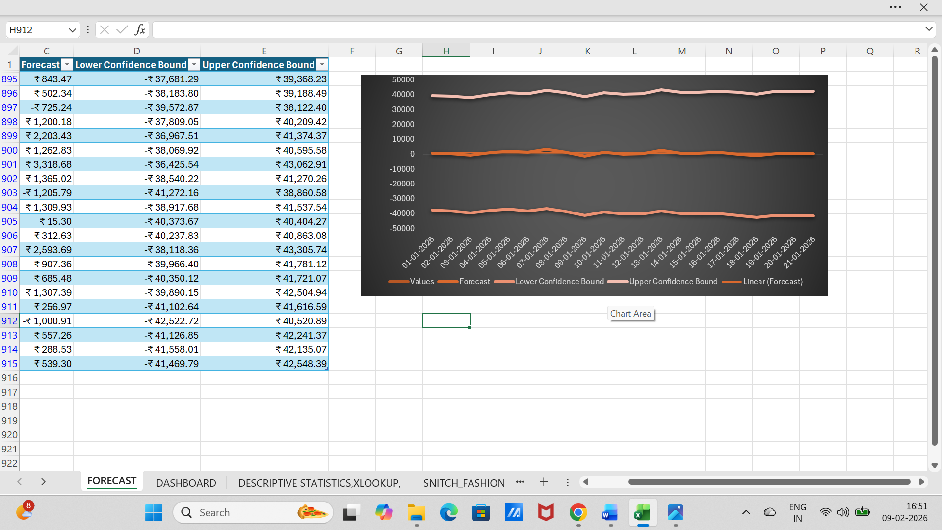

- Descriptive analysis:
    - Snitch sales mostly done in no sale value
    - There is so much negative sales in sales amount
    - Even sales amount marked as zero value
    - There must be heavy loss in profit
    - More than 2500 customer
sales occurred in 3 years.

- Diagnostic Analysis:
- We can increase the sales amount and discount range must be less than before because it shows >100%

- Predictive Analysis:
- B2B B2C sales segment must be valued and sales entry need to done regulary

- Prescriptive Analysis:
- Need to improves sales amount else company will so goes in heavy loss
Conclusion:
This project successfully analyzed [SNITCH FASHION SALES] by cleaning, transforming, and modeling raw data into an interactive dashboard. The findings providing valuable insights for future decision-making. The project enhanced efficiency in tracking [SALES]

